 | GODDARD TECHNICAL STANDARD | GSFC-STD-9001  CANCELLED  2018-03-14
Goddard Space Flight Center |  | Approved: 11-20-2007
Greenbelt, MD 20771 |  | Expiration Date: 12-31-2017

SPREAD SPECTRUM MODULATION FORMATS FOR NASA LINKS

November 20, 2007

DO NOT USE PRIOR TO APPROVAL.

DOCUMENT HISTORY LOG

Status | Document Revision |  | Approval Date | Description
Baseline |  |  | 05-22-2007 | Initial Release
 |  |  | 10-27-2015 | Extended until 12-31-2016
 |  |  | 07-11-2016 | Extended until 12-31-2017
CANCELLED |  |  | 03-14-2018 | Cancelled. The document no longer contains current and valuable information.

FOREWORD

This standard is published by GSFC, National Aeronautics and Space Administration (NASA) to provide uniform engineering and technical requirements for processes, procedures, practices, and methods that have been endorsed as standard for NASA programs and projects, including requirements for selection, application, and design criteria of an item.

This standard establishes uniform requirements for applying pseudo-noise (PN) spreading in NASA links and describes the existing links that use PN spreading.

Original signed by: Original signed by:

George Alcorn Steven Scott
Goddard Technical Standard Coordinator Chief Engineer

Original signed by: Original signed by:

Orlando Figueroa Marcus Watkins
Director of Applied Engineering Director of Office of Systems Safety
and Technology and Mission Assurance

SECTION |  | TABLE OF CONTENTS | PAGE
DOCUMENT HISTORY LOG |  |  | 2
FOREWORD |  |  | 3
TABLE OF CONTENTS |  |  | 4
LIST OF FIGURES |  |  | 5
LIST OF TABLES |  |  | 6
1. | SCOPE |  | 7
1.1 | Purpose |  | 7
1.2 | Applicability |  | 7
2. | APPLICABLE DOCUMENTS |  | 7
2.1 | General |  | 7
2.2 | Government Documents |  | 8
2.3 | Non-Government Documents |  | 8
2.4 | Order of Precedence |  | 8
3. | ACRONYMS AND DEFINITIONS |  | 9
3.1 | Acronyms and Abbreviations |  | 9
3.2 | Definitions |  | 9
4. | REQUIREMENTS |  | 13
4.1 | Introduction to Spread Spectrum Modulation Concepts |  | 13
4.1.1 | Basic Definition of Spread Spectrum |  | 13
4.1.2 | Different Types of SS Modulations |  | 14
4.1.3 | Advantages and Applications of DSSS |  | 14
4.2 | Direct Sequence Spread Spectrum Modulation |  | 17
4.2.1 | DSSS System Architecture |  | 18
4.2.2 | PN Code Basics |  | 20
4.2.3 | Generation of PN Codes |  | 21
4.3 | Use of Spread Spectrum in NASA Links |  | 25
4.3.1 | Capabilities and Characteristics of Existing NASA Systems |  | 25
4.4 | Requirements of PN Spread Modulations for NASA Systems |  | 29
4.4.1 | System Level Requirements for PN Spread Links |  | 29
4.4.2 | Network Element Requirements |  | 36
4.4.3 | User Element Equipment Requirements for PN Spreading |  | 36
Appendix A NASA Specific PN Code Requirements 43 8
Appendix B Algorithm for Selecting Primitive Polynomials 56

LIST OF FIGURES
FIGURE |  | PAGE
1 | Spread Spectrum Digital Communication Model | 13
2 | DSSS Spectral Occupancy Before and After Spreading | 15
3 | Spectral Usage of Multiple Users | 16
4 | Interference Susceptibility Reduction with DSSS | 16
5a | DSSS System Network Element Architecture | 18
5b | DSSS System User Element Architecture | 19
6 | Direct-Sequence Spreading | 20
7 | Fibonacci Implementation | 22
8 | Maximal Length Code Generator | 24
9 | Gold Code Generator | 25
10 | Time Transfer Interface | 39
11 | Time Transfer Interface Timing Diagram | 40
12 | Command Link Gold Code Generator | 44
13 | Command Link Gold Code Generator Initial Conditions | 45
14 | Return Mode 2 Link Gold Code Generator | 46
15 | Octal Conversion Example | 48
16 | Code Generator Configuration and Initial Conditions | 48
17 | Range Channel Code Generator | 49
18 | Range Channel Code Feedback Tap Example | 50
19 | Return Modes 1 and 3 Link Code Generator | 51
20 | Return Modes 1 and 3 Link Feedback Tap Example | 52
21 | Shuttle S-band Command Code Generator | 54
22 | Shuttle S-band Feedback Tap Example | 55

LIST OF TABLES
TABLE |  | PAGE
1 | Forward I Channel PSK Service Signal Parameters | 30
2 | Salient Characteristics of PN Codes for Forward Services | 32
3 | Forward Q Channel PSK Service Signal Parameters | 32
4 | Shuttle Forward I (Command) Channel Requirements | 33
5 | Return Service Signal Parameters | 34
6 | Bi-level Telemetry Involving PN Codes | 41
7 | NASA Unique Initial Conditions for PN Code Generation for Command Link | 44

SPREAD SPECTRUM MODULATION FORMATS FOR NASA LINKS

1. SCOPE
This standard describes the use of spread spectrum modulation in RF satellite communications systems and presents a detailed specification of the particular PN spread formats implemented in the low rate data transmission and PN range tracking services currently used by NASA systems. The functions and required capabilities of each element of PN spread links are also provided, including the typical signal flow and equipment characteristics and constraints involved.
Relevant information on the specification of PN sequences for use in NASA systems is also provided.
1.1 Purpose
This standard is intended to provide a comprehensive description of the PN spread spectrum modulation formats used in NASA links and to give associated technical requirements from the system level to the component level. The document is organized to support a range of uses, from providing basic system description, capabilities listing, and theoretical background for readers seeking a general understanding of existing systems to documenting the detailed technical requirements necessary for implementing hardware that is compatible with the current NASA systems.
1.2 Applicability

This standard is applicable to programs/projects planning to use and/or implement NASA compatible spread spectrum systems.

This standard may be cited in contract, program, and other Agency documents as a technical requirements document for NASA specific spread spectrum links. Tailoring of this standard for application to a specific program or project shall be approved by the Technical Authority for that program or project.

2. APPLICABLE DOCUMENTS
2.1 General

The documents listed in this section describe the performance and compatibility requirements for NASA’s Space Network (SN) and compatible user equipment systems. The characteristics and requirements in Section 4 of this standard are constituted largely of a subset of these requirements. The applicable documents are accessible via the NASA Technical Standards System at http://standards.nasa.gov, directly from the Standards Developing Organizations, or from other document distributors. The latest issuances of cited documents shall be used unless otherwise approved by the assigned Technical Authority.

2.2 Government Documents
- 450-SNUG, Space Network Users’ Guide (SNUG), Revision 9, April 2007
- 451-PN CODE-SNIP, Space Network Interoperable PN Code (SNIP) Libraries, Revision 1, November 1998
- 531-RSD-IVGXPDR Performance and Design Requirements and Specification for the Fourth Generation TDRSS User Transponder, Review Copy, February 1996
- 530-RSD-WSC Requirements Specification for the White Sands Complex (WSC), Revision 1, June 1997
2.3 Non-Government Documents
- Glas, Jack P.F. (December 1996). Non-Cellular Wireless Communication Systems, PhD- thesis. Delft University of Technology. ISBN: 90-5326-024-2 Non-Cellular Wireless Communication Systems
- Choi, Byoung Jo. (December 1997). Spreading Sequences.

2.4 Order of Precedence
When this standard is applied as a requirement or imposed by contract on a program or project, the technical requirements of this standard take precedence, in the case of conflict, over the technical requirements cited in applicable documents or referenced guidance documents.
3. ACRONYMS AND DEFINITIONS
3.1 Acronyms and Abbreviations

DSSS Direct Sequence Spread Spectrum
ESA European Space Agency
JAXA Japan Aerospace Exploration Agency
MA Multiple Access
MOC Mission Operations Center
PN Pseudo-random Noise
PFD Power Flux Density
PSD Power Spectral Density
RF Radio Frequency
SQPN Staggered Quadrature Pseudo-random Noise
SN Space Network
SS Spread Spectrum
TCXO Temperature Compensated Crystal Oscillator
VCO Voltage Controlled Oscillator

3.2 Definitions

Acquisition: In RF communications systems, the process by which the receiver tracking loops lock to estimates of the received signal phase and timing as a necessary precursor to data detection.

Acquisition Time: The time interval required for a receiver in an RF communications system to complete the acquisition process.

Bandwidth (BW): The difference between the limiting frequencies of a continuous frequency band, or the range of contiguous frequencies within which the performance of a device, in respect to some characteristic, falls within specified limits.

Baseband: The original band of frequencies which contain the information in a data signal prior to modulation.

Baseband Signaling: Transmission of a digital or analog signal at its original frequencies; i.e. a signal in its original form, not changed by modulation.

Baud: A unit of modulation rate. One baud corresponds to a rate of one unit interval per second, where the modulation rate is expressed as the reciprocal of the duration in seconds of the shortest unit interval.

Baud Rate: Rate at which a characteristic (i.e., phase, frequency, amplitude) of a carrier wave is changed by the modulating signal.

Bit (Binary Digit): The basic unit of information in a binary communications system (holding a value of 0 or 1).

Bit Error Ratio (BER): In a communications system, the ratio of data bits which are erroneously detected by the receiver to the total number of data bits received.

Bit Synchronization: Synchronization in which the decision instant is brought into alignment with the received bit, i.e. the basic signaling element.

Carrier Frequency: The frequency of the signal onto which the baseband signal is modulated.

Channel: Any medium that a communication link uses to transport the electromagnetic waves which includes data.

Chip: The most elemental component of the time domain representation of a PN sequence; that is, the longest duration portion of the PN sequence during which the signal parameters are approximately constant.

Chip Rate: In direct-sequence-modulation spread-spectrum systems, the rate at which the information signal bits are transmitted as a pseudorandom sequence of chips.
Note: The chip rate is usually at least ten times the information bit rate.

Coherent: In an RF communications system, Signal A is considered to be coherent with Signal B if their carrier frequencies are related by a known, fixed ratio.

Correlator: The SS receiver component that demodulates a Spread Spectrum signal.

Customer: See User.

De-spreading: The process used by a correlator to recover narrowband information from a spread spectrum signal.

Detection: In a communications system, the process by which the receiving equipment produces an estimate of the transmitted sequence based on the noisy received signal.

Direct Sequence Spread Spectrum (DSSS): See Section 4.2.

Forward Link: An RF communication link starting from the NASA network to the user of that network. A forward link can have multiple hopping points along the path.

Modulation: The process, or result of the process, of varying a characteristic of a carrier, in accordance with an information-bearing signal.

Network: The element of a two-way RF link responsible for initiating and managing the contact and performing range calculation functions (if applicable). A network may include one or more ground stations.

Pseudo-Random Noise Sequence: A Pseudo-random Noise (PN) sequence is a sequence of binary numbers, +1 and -1 (or 1 and 0), which appears to be random; but is in fact perfectly deterministic.

PN Chip Jitter: PN code chip jitter is defined as the unwanted phase variations of the PN code chip clock measured in degrees RMS.

PN Chip Rate: See definition for Chip Rate above.

PN Chip Skew: PN chip skew is the deviation of the chip transitions between the I (or command channel for forward) and the Q (or range channel for return) from the ideal time delay.

PN Code: See Section 4.2.

PN Epoch: The PN Epoch is a repeating reference pattern within the code used for the acquisition process and ranging.

PN Sequence: See Section 4.2.

PN Spreading: PN spreading is a process used to distribute or spread the power of a signal over a bandwidth which is much greater than the bandwidth of the signal itself. PN de-spreading is the process of taking a signal in its wide PN spread bandwidth and reconstituting it in its own much narrower bandwidth.

Power Flux Density (PFD): The rate of flow of electromagnetic energy per unit area is used to measure the amount of radiation at a given point from a transmitting antenna. This quantity is expressed in units of watts per square meter (W/m²) or milliwatts per square cm (mW/cm²).

Power Spectral Density (PSD): PSD is the average power in the signal per unit bandwidth.

Quadrature Phase Shift Keying Modulation: Quadrature Phase Shift Keying (QPSK) is a form of Phase Shift Keying in which two bits are modulated at once, selecting one of four possible carrier phase shifts (0, 90, 180, or 270 degrees). QPSK allows the signal to carry twice as much information as ordinary PSK using the same bandwidth. In QPSK modulation, a cosine carrier is varied in phase while keeping a constant amplitude and frequency.

Return Link: An RF communication link from the user of the NASA network to the NASA network. A return link may have multiple hopping points along the path.

Shift Register: A storage device consisting of a data input port, a clock input port, an output port, and a single bit memory storage; the shift register retains the value currently stored in memory at its output port until such time as an input clock pulse is received. At this time, the register sets the value in memory to the value on its input port.

Spread Spectrum: A wideband modulation which imparts noise-like characteristics to an RF signal.

Staggered Quadrature PN (SQPN) Modulation: A modulation format wherein the PN spread data sequence is modulated onto an RF carrier using a variation of QPSK modulation in which one channel is delayed by one half of a modulation symbol period (in this case, one half of a PN chip period) with respect to the other channel.

User: The element in an RF communications link which exchanges data with the network element. The user is responsible for any required transponder/transceiver operations (i.e. generation of coherent return link carrier and synchronized PN sequence).

4. REQUIREMENTS
This section provides the technical information and requirements associated with implementing PN Spread modulation modes in NASA links. Section 4.1 provides a basic introduction to Spread Spectrum (SS) modulation concepts, emphasizing the Direct Sequence Spread Spectrum (DSSS) approach addressed in this standard. Section 4.2 discusses implementation of DSSS modulation at the system level, including also a discussion of PN code selection. Section 4.3 provides relevant information concerning the PN Spread modulation modes used in NASA’s Space Network. These Sections form the basis for the PN Spread modulation system and sub-system level requirements given in Section 4.4.
  - Introduction to Spread Spectrum Modulation Concepts

This section presents an introduction to Spread Spectrum concepts. Section 4.1.1 presents a basic definition of Spread Spectrum modulation. Section 4.1.2 describes several means of implementing SS modulation. Section 4.1.3 expands upon these concepts by detailing some of the major advantages of DSSS.
    - Basic Definition of Spread Spectrum
Spread Spectrum (SS) is a family of communications techniques in which the RF bandwidth used to transmit a given data signal is much wider (typically several times wider) than what would normally be used with non-SS modulation techniques.
There are a number of ways to implement spread spectrum modulation. In each of these techniques, a pseudo-random signal is used to control / modulate some characteristic of the data signal transmission. This process is called the spreading operation. Although the spreading signal is deterministic, periodic, and known by both the transmitter and receiver; it is independent of the data signal and is chosen to appear as random as possible.
The effect of the spreading operation is to distribute the information in the data signal over a significantly larger bandwidth. At the receiver, a similar algorithm is used, employing the identical periodic pseudo-random signal (which must be synchronized to that of the transmitter), to isolate or extract the desired lower bandwidth data signal from the received higher bandwidth spread signal. This is called the de-spreading operation. These processes are illustrated generically in Figure 1.
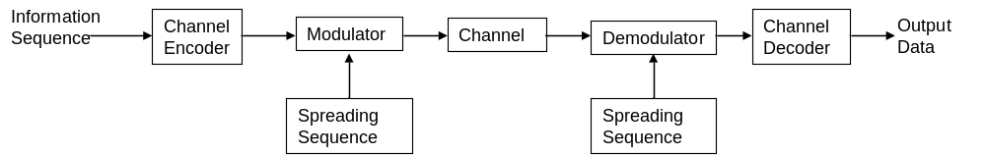

Figure 1—Spread Spectrum Digital Communication Model

A key parameter in all spread spectrum systems is the spreading factor given in Equation 1 (also equivalent to the processing gain in DSSS) which can be expressed as the ratio of transmission bandwidth (the bandwidth of the spread signal) and the information bandwidth (the bandwidth of the baseband data signal):
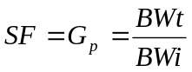 (1)
This factor impacts each of the SS advantages discussed below. For spread spectrum systems it is, in general, advantageous to have the largest Spreading Factor / Processing Gain that is possible, subject to bandwidth constraints.
    - Different Types of SS Modulations
Some commonly used spread spectrum techniques include DSSS, frequency hopping spread spectrum and time hopping spread spectrum.
In frequency hopping SS systems, the data signal is modulated directly onto an RF carrier (using a traditional non-SS technique such as QPSK) and the frequency of this carrier jumps rapidly between a number of defined frequencies as a function of the pseudo-random spreading signal. At the receiver, the carrier tracking loop reference also shifts between the defined frequencies following the same unique pattern.

In time hopping spread-spectrum the information-bearing signal is not transmitted continuously. Instead the signal is transmitted in short bursts where the times of the bursts are decided by the spreading code. To achieve an equivalent information transfer rate as would be realized with a non-spread system (where the data transfer is continuous), the instantaneous data rate (when the system is transmitting) is significantly increased. This is the mechanism by which the bandwidth expansion occurs.
In Direct Sequence Spread Spectrum (DSSS), the spreading signal is a pseudo-random noise (PN) sequence. The bits in the data signal are modulo-two added with the much higher rate PN code. This effectively increases the bandwidth of the transmitted signal to that of the modulated PN sequence. At the receiver, the received sequence is multiplied by the same PN sequence to remove the spreading.
The DSSS implementation employed by NASA is described in this standard.
    - Advantages and Applications of DSSS
Systems incorporating the DSSS modulation format described in this standard offer a number of advantages over non-spread techniques. These include reduced Power Flux Density (PFD), capability of supporting multiple simultaneous users via Code Division Multiple Access (CDMA), reduced susceptibility to interference (including intentional jamming) and multi-path fading, and decreased probability of signal interception.
Reduced PFD: Figure 2 demonstrates the Power Spectral Densities (PSDs) of a data signal before and after spreading. The effect of the spreading is to increase the signal bandwidth (by the spreading factor given in Equation 1). However, since the energy per bit required for data transmission is fixed, the magnitude of the PSD (and thus the associated PFD) of the spread signal is reduced by the same ratio. At the receiver side, de-spreading has the opposite effect – transforming the wideband, low-power spread signal into the original narrow-band high power data signal PSD. The terminology “processing gain” defined above refers to the relative increase in the PSD level realized by de-spreading.

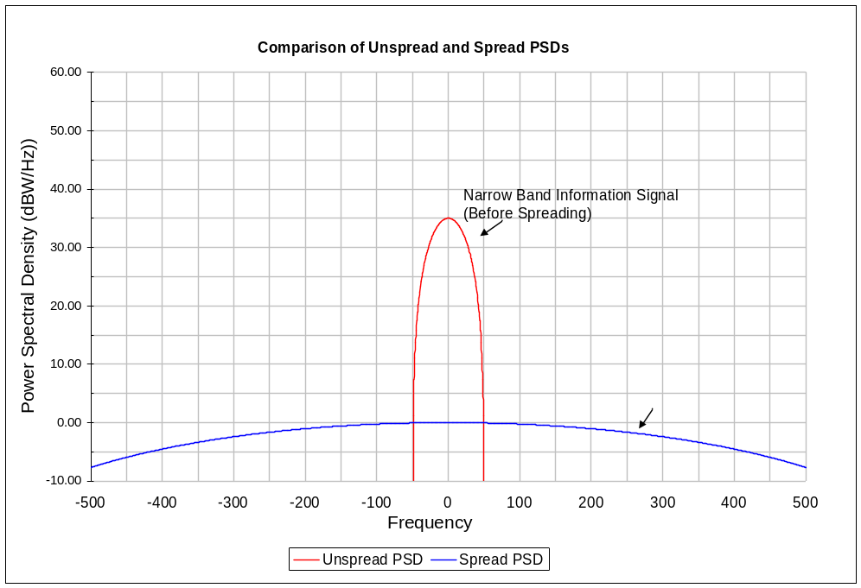
Figure 2— DSSS Spectral Occupancy Before and After Spreading

Multiple Simultaneous Users: One of the key applications for NASA PN Spread systems is the SN multiple access service. In CDMA systems, multiple users utilize the same frequency band simultaneously to transmit PN spread signals. As depicted in Figure 3, the composite RF signal in this band then is the sum of the multiple RF DSSS signals plus any noise or external interference. Each of the N users is assigned a unique PN spreading sequence. The properties of these sequences are such that when a data signal is spread using one sequence, de-spreading with another sequence produces little, if any processing gain. This allows receivers operating on the composite signal to pull out the data signal corresponding to their assigned PN sequence. After de-spreading, the composite PSD consists of the desired data signal narrow-band high power component plus the wideband, low power contributions from the other users’ signals and noise. Since the wideband low power PSD contributions from other users are mostly flat over the narrow desired signal frequency band, they are often described as “noise-like” interference, and the effect of adding more users is characterized as “increasing the noise floor”.

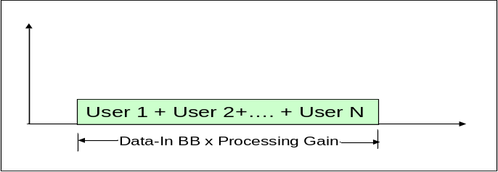
Figure 3 — Spectral Usage of Multiple Users

Reduction in Interference Susceptibility: Another major advantage of DSSS techniques is a reduction in the susceptibility to RF interference, whether that interference is accidental or due to deliberate jamming efforts. Figure 4 demonstrates the mechanism through which this occurs. In Panel 1, a high power narrow band interferer is shown with its PSD superimposed upon that of the desired PN spread signal. The noise floor is shown to provide a context to compare the relative power levels. In Panel 2, the effects of the de-spreading operation at the receiver are shown. It is important to note that in the receiver, the entire composite signal (noise, intended signal and interferer) are all modulo-two added to the high rate PN sequence. This has two effects. First, it re-constitutes the original high power narrowband desired signal. Second, and more importantly, it effectively spreads the power in the interfering signal over the wider PN sequence bandwidth. In Panel 3, after the receiver filtering, it can be seen that the desired signal to interference signal power ratio is significantly improved (by a factor approximately equal to the processing gain).

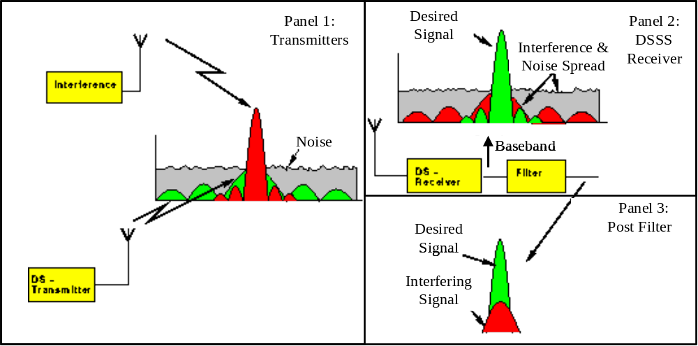
Figure 4 — Interference Susceptibility Reduction with DSSS

A related benefit of DSSS modulation techniques is the reduction in susceptibility to multi-path effects. In this case, the mechanism is more direct. Multi-path is a narrowband phenomenon. By spreading the energy in a data signal uniformly over a wide bandwidth, the impact of multipath degradation is effectively reduced.
Decreased Probability of Signal Interception: The noise-like properties of the spreading sequences used in a DSSS system, and the relatively low PSD of the RF signal make it very difficult for receivers to detect the presence of a PN spread signal without knowing the PN code in use. This same characteristic also decreases the probability that a PN spread signal will interfere with other systems in the same frequency band.
Capability of Supporting PN Ranging Operations: In a system where RF links between two elements employ PN spread modulation formats, it is possible to calculate range estimates using the PN sequences. The mechanism by which this is accomplished is described in the series of steps below:
- The element functioning as the network generates a PN sequence, uses this sequence to spread forward link data and transmits the signal to the second element.
- The second element (generally a transponder or tranceiver) generates the same PN sequence and uses it to de-spread the forward link data. Note that in order to do this, it must align (in time) its generated sequence with that of the received signal.
- It then generates a second PN sequence (to spread the return link data), aligns the epoch of this sequence with that of the received signal, spreads the return link data and transmits the resulting spread signal to the first element (network).
- The first element receives the return link signal, generates a matching PN code, aligns it to the epoch of the received signal, and de-spreads the return link data.
- The offset between the epochs of the transmitted forward link PN sequence and the received return link sequence is a function of the total round trip delay time. By removing the processing time delays and dividing by the speed of light, estimate of the (2 way) range is obtained.

  - Direct Sequence Spread Spectrum Modulation
This section describes issues and approaches relative to the implementation of DSSS techniques in RF communications systems. Section 4.2.1 provides a basic overview of the architecture of an RF communications system employing DSSS modulations, and addresses some of the relevant terminology. Section 4.2.2 discusses significant characteristics of the PN sequences used, including correlation properties. Section 4.2.3 discusses the particular PN code families used for NASA PN Spread systems and their significant properties and applicability to various types of links.
The descriptive material presented in these sections provides a more thorough understanding of PN spread modulation systems and also is useful in defining the requirements provided in Section 4.4.

    - DSSS System Architecture

Figures 5a and 5b contain block diagrams of the network and user elements in a DSSS RF communications system. The network element transmits forward service data to the user element and the user element transmits return service data back to the network. In these Figures, a QPSK type modulation format is used to transmit the PN spread signals. This modulation format is typically referred to as Quadrature PN (QPN) modulation, or Staggered Quadrature PN (SQPN) modulation if the QPSK symbols are staggered. However, a BPSK modulation format could also be used to transmit the PN spread data.

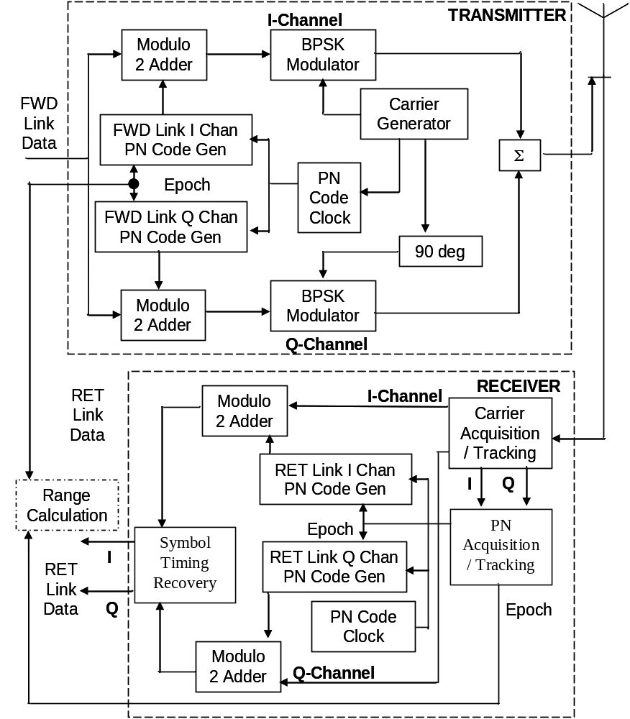

Figure 5a – DSSS System Network Element Architecture

In both the network and the user transmitters, data bits (or coded data symbols) are split into I and Q channels which are spread separately by modulo-2 adding the data to PN sequences. The spreading operation is depicted conceptually in Figure 6. In these Figures, distinct and potentially different PN sequences (with a common clock and a synchronized epoch) are used on the I and Q channels for both the forward and return signals. Again, this approach is not a requirement for DSSS (for example, one could use the same spreading sequences on both channels), but it does represent how some NASA PN spread links are implemented.
Spread data sequences are input to BPSK modulators on each channel, and the outputs of these are combined to produce the QPN/SQPN signal. At the receiver side, carrier acquisition, PN acquisition, de-spreading, and symbol timing recovery are depicted as separate operations although they are often performed in tandem.

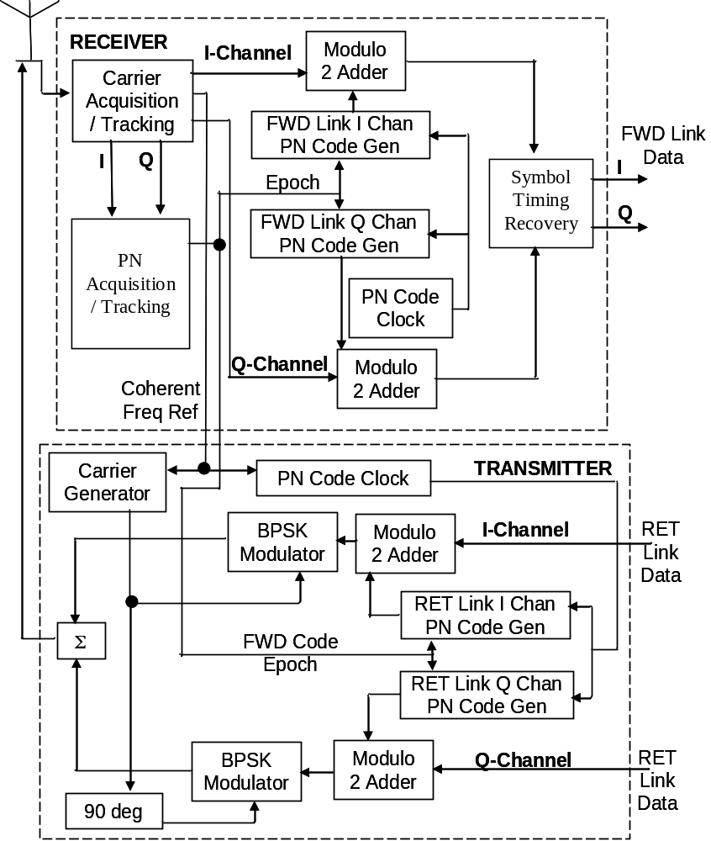
Figure 5b – DSSS System User Element Architecture

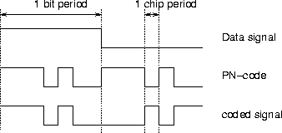
Figure 6 — Direct-Sequence Spreading

PN acquisition is accomplished using a correlator to compute the timing offset between the reference PN sequence generated internally and the received sequence. Once this offset, or epoch, is computed, it is used to de-spread the data signals on the I and Q channels.
The user element in Figure 5b is configured to synchronize the epoch of the return signal spreading sequences with the detected forward signal epoch. This facilitates the ranging calculation depicted in Figure 5a.
    - PN Code Basics
This section presents an overview of pseudo-random noise codes. In Spread Spectrum systems, the spreading signal is formed by continually repeating a finite length PN code. To be usable for direct-sequence spreading, this PN code (composed of N_{DS} binary units called chips) should exhibit the following characteristics:
- Codes must have a sharp (1-chip wide) autocorrelation peak to enable code-synchronization. (See discussion of autocorrelation below).
- The codes must have a low cross-correlation value. The lower this cross-correlation, the more users that can be allowed in the system. This holds for both full-code correlation and partial-code correlation. (See discussion of cross-correlation below).
- The codes should be “balanced”, meaning that the difference between the number of ones and zeros in the code may be no greater than 1. This requirement is necessary for good spectral density properties (spreading the energy equally over the whole frequency-band).
Autocorrelation
The autocorrelation of a signal is a measure of how easy it is to differentiate between the signal and every time-shifted variant of itself (over successive time intervals). Autocorrelation for a finite, discrete signal is defined in Equation 2 where T is a time delay and L is the sequence length.

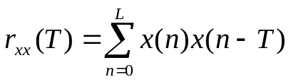 Un-normalized (2)
A signal with an autocorrelation of zero is said to be orthogonal to a time-shifted version of itself. PN sequences used for DSSS systems should have a sharp autocorrelation property (meaning that the value of the autocorrelation, which should be maximal at T=0, should diminish sharply as the magnitude of T increases. This property simplifies the PN acquisition process.
Cross Correlation

Cross correlation is similar to an autocorrelation except that it is computed between two different signals, for example – between two particular PN codes that are members of a PN code family. As with the autocorrelation, it is computed as the sum of the cross products between the two signals at different lags. Cross correlation for finite length discrete signals is defined in Equation 3.

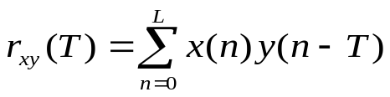 Un-normalized (3)

Cross correlation is generally used when measuring information between two different time series.
If the cross correlation is:
- 1 The second sequence matches the first sequence
- 0 There is no relation at all between the sequences
- -1 The second sequence is an inverted form of the first sequence.
The signals are said to be orthogonal when all pair-wise cross correlations of two signals are 0.
    - Generation of PN Codes
PN codes are typically generated using Linear Feedback Shift Register (LFSR) circuits. These circuits can be described by a generator polynomial, which uniquely describes the circuit. For a given generator polynomial, there are two ways of implementing LFSR. One is called the Galois Feedback Generator. This circuit uses only the output bit to add several stages of the shift register. It is most desirable for high speed hardware implementations, as well as when the generator is implemented in software.
The other implementation structure is known as the Fibonacci feedback generator. This approach is used in maximal length sequences and Gold code generators. Figure 7 shows an example of a PN code generator based on the Fibonacci feedback approach, and gives the associated polynomial.

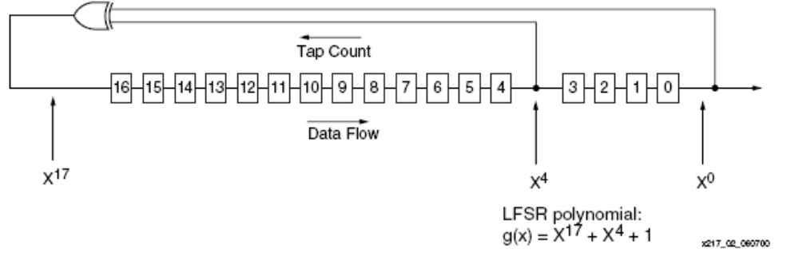
Figure 7 — Fibonacci Implementation

Relation of Polynomial to Shift Register Tap Locations

The combination of taps and their location is specified by the generator polynomial. An example polynomial is given as:

P(x) = X¹⁷ + X⁴ + 1

Various conventions are used to map the polynomial terms to register stages in the shift register implementation. The convention used for NASA applications is explained below.

In the polynomial P(x) = X¹⁷+ X⁴ + 1, the trailing "1" represents X⁰, which is the output of the last stage of the shift register. X⁴ is the output of register stage 4 and X¹⁷ the output of the XOR.

Some key points to note about LFSRs and the polynomial used to describe them are:

- The last tap of the shift register is the leading "1" and always used in the shift register feedback path.
- The length of the shift register can be deduced from the exponent of the highest order term in the polynomial.
- The highest order term of the polynomial is the signal connecting the final "XOR" output to the shift register input. It does not feed back into the parity calculation along with the other taps identified in the polynomial.

      - PN Code Families
Among the various families of PN codes used for DSSS applications, there are some which exhibit perfect (orthogonal) cross-correlations between component codes and others which exhibit very low cross-correlations. An example of a code family with orthogonal codes is the set known as Walsh codes. Examples of PN codes with low-cross correlation are Maximal Length codes and Gold codes. These are explained in detail below. Other codes in this category include M-sequences and Kasami-codes.
Code-selection has a large impact on the performance of the system. Code selection and cross-correlation properties are key performance factors. Orthogonal codes offer the advantage of minimizing mutual interference in multiple access systems. They are best used in systems where the PN sequence is synchronous with the data sequence. However, in systems where the data and PN sequences are asynchronous (as in NASA PN spread links), PN codes with low (bit non-zero) cross correlation properties are sometimes preferable.
NASA systems use shift-register sequences. Shift register codes are not orthogonal but they have a narrow autocorrelation peak. When the length of such a shift-register used to generate a PN code is given by N, the period N_{DS} of the shift-register code will be:
N_{DS} = 2^{N} - 1
The code families used in NASA Spread Spectrum systems include Gold codes and Maximal Length codes. All of the codes in a particular family are generated from a single circuit or a related set of circuits. Circuits to generate PN codes belonging to the class of Gold codes differ only in the initial conditions of the shift registers. Circuits to generate Maximal Length Codes differ only in the feedback taps of the circuit.
There are a finite number of codes in each of these families. These are further allocated between the different space agencies (e.g., NASA, ESA and JAXA) in order to allow for interoperability between agencies without mutual interference. There is also a library of unassigned PN codes which NASA can use in case the need emerges. Within NASA, the codes are currently used in the Space Network for a number of services which are detailed in Section 4.3. These include:
  - Gold Codes: Forward Command Channel (I Channel) and Return DG1 Mode 2
  - Maximal Length Codes: Forward Range Channel (Q Channel), Return DG1 Modes 1 and 3, and Forward Shuttle S-band Command Links.

Maximum Length Codes

A maximal length sequence for a shift register of length N is referred to as an M-sequence. Such sequences can be created by applying a single shift-register with a number of specially selected feedback-taps. An 18-stage shift register is shown in Figure 8 with N selectable taps.

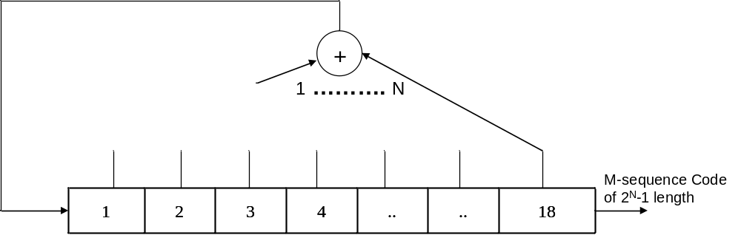
Figure 8 — Maximal Length Code Generator
The number of possible codes is dependent on the number of possible sets of feedback-taps that produce an M-sequence. These sequences have a number of special properties. Some of those properties which will be used in the code selection process are:
- M-sequences are balanced: the number of ones exceeds the number of zeros by only 1.
- The spectrum of an M-sequence has a sync² envelope.
- The shift-and-add property can be formulated as follows:
T^{k} u = T^{i} u T^{j} u
where u is an M-sequence, by combining two shifts of this sequence (relative shifts i and j) we obtain again the same M-sequence, yet with another relative shift.
- The auto-correlation function is two-valued:
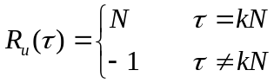
where k is an integer value, and τ is the relative shift.
There is no general formula for the cross-correlation of two M-sequences, only some rules can be formulated. A so called “preferred pair'” is a combination of M-sequences for which the cross-correlation only shows 3 different values: -1, -2^{[(N+2)/2]} and 2^{[(N+2)/2]}. Preferred pairs for shift-registers with a length equal to 4k, where k is an integer, do not exist.
See Appendix B for Maximum Length sequence algorithm for selecting the primitive polynomial for NASA links.

Gold Codes Basics

Gold sequences form a large class of sequences that have good periodic cross-correlation properties. Gold codes are not orthogonal, but have low cross correlation at arbitrary delay. Hence, Gold codes perform well for asynchronous systems. Gold Codes contain fixed feedback tap locations and user specific initial conditions.

Gold (and Kasami) showed that for certain well-chosen m-sequences, the cross correlation only takes on three possible values, namely -1, -t or t-2. Two such sequences are called preferred sequences. Here t depends solely on the length of the LFSR used. In fact, for a LFSR with N memory elements,
if N is odd, t = 2^{(Nl+1)/2} + 1, and
if N is even, t = 2^{(N+2)/2} + 1.
Gold codes are constructed by EXOR-ing two m-sequences of the same length with each other as shown in Figure 9. Thus, for a Gold sequence of length m = 2^{N}-1, two LFSRs are used, each of length 2^{N}-1. If the LSFRs are chosen appropriately, Gold sequences have better cross-correlation properties than maximum length LSFR sequences.

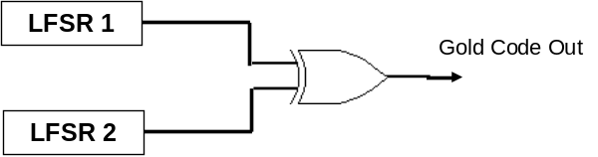
Figure 9 — Gold Code Generator

  - Use of Spread Spectrum in NASA Links
NASA employs Direct Sequence Spread Spectrum (DSSS) modulation in the Space Network for low rate data transfer, ranging services, and to support multiple access modes. PN spreading is performed on both forward and return services. Capabilities and characteristics of the Space Network are explained briefly in Section 4.3.1 including coherent, PN acquisition, and different service modes. 450-SNUG may be consulted for a complete understanding of these subjects.
    - Capabilities and Characteristics of Existing NASA Systems
The Space Network provides forward and return data communication services and tracking services. PN spreading is used in S-band and Ku-band forward and return services and in Ka-band forward data services. Note that S-band services include both Multiple Access (MA) and Single Access (SSA) services. Tracking services that use PN codes are Range and Customer Time Transfer. Tracking services are not stand alone services rather they are integrated into the forward and return services. Only the SN services that use DSSS and their requirements relating to the PN coding are provided in the following sections. The 450-SNUG may be consulted for a complete understanding of SN services and requirements. Note that other agencies (ESA and JAXA) utilize similar terminology to define PN spread services with identical characteristics.
The following PN spread signal formats are used in NASA’s Space Network:
- Low Data Rate Forward I Channel Signal Format
- Low Data Rate Forward Q Channel Signal Format
- Low Rate Return DG1 Mode 1 Channel Signal Format
- Low Rate Return DG1 Mode 2 Channel Signal Format
- Low Rate Return DG1 Mode 3 Channel Signal Format
- Shuttle S-band Forward I Channel Signal Format.

Coherent and Non-coherent Modes:
In a coherent RF link, the user element transmitted return link carrier frequency and PN code clock frequency (if applicable) are derived from the forward link carrier frequency received from the network element. For coherent PN spread return links, the return PN code length is identical to the length of the received forward service range channel PN code. The customer return I channel PN code epoch is synchronized with the epoch of the received forward service range channel PN code.
For non-coherent modes, the customer platform transmitted return link carrier frequency and PN code clock frequency (if applicable) are derived from an on-board local oscillator.
A customer transponder is required for coherent service whereas a transceiver may be used for non-coherent service.
PN Acquisition:
The forward link carrier frequency and PN chip rate are usually Doppler compensated on a continuous basis in order to minimize the Doppler resolution requirements of the customer receiver and to facilitate reacquisition by customer platform in the event of loss of lock of the forward service signal. The Doppler compensation is performed at the start of service so it arrives at the customer platform receiver at the center frequency specified in the customer schedule. The customer platform receiver then acquires the forward link PN codes (Command I Channel [PN Short Code] and Range Q Channel [PN Long Code]).
During the customer platform receiver acquisition period no commands should be sent via the forward link. The customer platform initially searches for the PN Short code (I channel) to acquire the forward signal. If the customer sends commands and thus command modulation there is an increased possibility of false PN lock within the customer platform receiver. In the event of a false lock the customer platform will not be able to correlate the PN long code.
Once the customer equipment is locked to the forward link command I channel PN code, two functions take place:
The receiver PN correlation process autocorrelates the forward spread spectrum signal to allow recovery of the forward carrier. This carrier is then used to coherently generate the return carrier for the return link acquisition at a transmit frequency of 240/221 times the received (network forward) frequency.
The customer equipment locally generated PN Long Code will be synchronized with the correlated network PN Long Code (Q-Range Channel) by using the PN-Epoch. The PN Epoch is a repeating reference pattern within the code used for the acquisition process and ranging. The modified customer platform transmitter Long PN code, containing the I and/or Q channel data and PN Epoch synchronized with the received PN Epoch from network, is then used to modulate the now coherent carrier for network return link acquisition.

Return signal Doppler compensation is performed to allow implementation of receivers with narrow acquisition and tracking bandwidths.
Forward Services PN Spread Signal Formats:

SN forward services with data rates equal to and below 300 kbps are recommended to incorporate spread spectrum modulation techniques to satisfy NTIA power flux density restrictions. 300 kbps is the achievable data rate limit for PN spread links with a PN chip rate of 3 Mcps; based on the general PN spreading requirement of 10:1 ratio of PN chip rate to symbol rate. This modulation scheme employs a non-staggered QPSK format with PN spread data on the I channel, also known as the Command channel, and a ranging PN sequence with no data on the Q channel, also known as the Range channel. Spread Spectrum BPSK (SS-BPSK) is also possible for forward services.

The command channel makes use of a shorter (and thus rapidly acquirable) PN code. The Range channel contains a longer PN code which satisfies the range ambiguity resolution requirements. The length of the command channel PN code is 2¹⁰-1, where the length of the range channel PN code is exactly 256 times the command channel PN code length. Also, the codes are synchronized (the first chip in the command channel code occurs at the same point in time as the first chip in the range channel code). Once the customer platform acquires the command channel epoch, acquisition of the range channel PN code timing is greatly simplified and thus the overall acquisition time is reduced.

The PN code chip rate is coherently related to the transmit frequency in all cases except for shuttle services. This feature permits the customer platform receiver to use the receiver PN code clock to predict the received carrier frequency, thereby minimizing receiver complexity and further reducing acquisition time. Shuttle PN chip rate and carrier frequency are independent. Further information on shuttle services is provided in 530-RSD-WSC.

For data rates < 300 kbps, the forward service data is directly modulo-2 added to the command channel PN code sequence. The forward service data will be asynchronous with the carrier and the PN code. When the command channel does not contain any actual forward service data, the forward service command channel signal is the command channel PN code sequence. A 10 to 1 power ratio (command channel to range channel power) is normally used.

Shuttle forward services use PN coding for I (command channel). The range channel does not use PN codes.

Return Links Using Spread Spectrum:

Return services that use PN spread modes are called Data Group 1 (DG1). For all DG1 modes, the PN code clock must be coherently related to the transmitted carrier frequency. This feature permits the customer platform transmitter to use a common source for generating the carrier and the PN code clock frequencies. For return service DG1 Modes 1 and 3, the carrier frequency is coherently derived from the received forward link frequency and the epoch of the return service PN code (the longer ranging code) is synchronized with the received forward service range channel PN epoch. The three DG1 modes are summarized below:

- DG1 Mode 1 service supports up to 300 kbps uncoded on the I and Q channels (600 kbps uncoded total) using SQPN modulation with the a PN spreading code (ranging code - length 256 * 2¹⁰ -1) whose epoch is synchronized to that of the received forward service range channel code. It supports ranging and 2-way Doppler tracking services. Spread Spectrum BPSK can also be used in this mode of operation.

DG1 Mode 2 is a non-coherent service. It supports the same data rates as DG1 Mode 1 but provides only 1 way Doppler. There is no requirement for coherent turn around or synchronization of the PN code. DG1 Mode 2 links use the short PN code (length 2¹⁰ – 1) on both I and Q channels. Spread Spectrum BPSK can also be used in this mode of operation.

DG 1 Mode 3 is a coherent combination service. Up to 300 kbps (uncoded) can be placed on the I channel, which is PN spread in a manner identical to that used with DG1 Mode 1. This allows PN ranging. Coherent turnaround of the carrier frequency also facilitates support for 2-way Doppler. Unlike mode 1, however, the Q channel in mode 3 is unspread, high rate data. The maximum data rate for the Q channel is 3 Mbps (uncoded) for MA service, 6 Mbps (uncoded) for S-band single access service, and 6 Mbps (uncoded) for Ku-band single access. Note that S-band signals requiring bandwidths greater than 6 MHz may be difficult to obtain. Please contact the GSFC Spectrum Manager.

Tracking Services Using Spread Spectrum:
The tracking services that use PN spreading are range measurements and customer time transfer. Note that tracking services are not stand alone services; rather they are integrated into the forward and return services.
Range measurement can be achieved during DG1 modes1 and 3 operations by measuring the time elapsed between the transmission of a PN code epoch on the forward link and the reception of the turned-around PN code epoch on the return link. Only two-way range measurements are provided. When channel delays are subtracted; the result provides a resolution of 1 nanosecond.

Customer (User) Time Transfer is performed during DG1 modes 1 and 3 operations. The time transfer function provides a method to acquire the data necessary to update a customer platform clock. It gives the customer Mission Operations Center (MOC) the ability to determine the time difference between the on-board platform clock and Universal Time Coordinated (UTC). To facilitate the time transfer measurement, the customer must cause the platform to note and store the platform clock reading at the time of arrival of the epoch portion of the PN range code. The clock reading must be included in the platform telemetry for processing by the MOC. It is the MOC’s responsibility to make the necessary adjustment to the customer clock using the SN-supplied data.

  - Requirements of PN Spread Modulations for NASA Systems

This section details the functional and performance requirements of NASA systems employing the PN spread modulation formats covered by this standard. Section 4.4.1 provides system level requirements. Section 4.4.2 and 4.4.3 provide network and user element requirements respectively. The basis for these requirements is the objective of ensuring compatibility between equipments developed to this standard and existing SN infrastructure / SN customer platform.
    - System Level Requirements for PN Spread Links

This section provides requirements that are applicable on a system level for NASA links using Spread Spectrum modulation. Section 4.4.1.1 provides service availability requirement and Section 4.4.1.2 provides requirements on each of the service modes.

The system shall support PN code assignments to specific platforms as assigned by the GSFC Spectrum Manager.

      - Service Availability Requirements
Systems designed to support NASA PN spread modulation format shall provide forward and return data transfer services. Forward services shall be capable of supporting data transfer and range data. Return services shall be capable of supporting coherent mode of operation if PN ranging is necessary. These services shall be compatible with NASA’s existing Space Network system PN spread modes. Systems using PN spread modulations on forward links shall comply with the requirements specified in Section 4.4.1.2.1. Systems using PN spread modulations on the return service shall comply with requirements specified in Section 4.4.1.2.2.
      - Service Mode Requirements
        - Forward Services

NASA Forward link services using spread spectrum shall meet the requirements specified in Sections 4.4.1.2.1.1 and 4.4.1.2.1.2 below. These Sections detail the signal format requirements applicable to the Command and Range channels respectively. Shuttle forward link specifications are provided in Section 4.4.1.2.1.3. These sections provide only those parameter requirements relating to signal compatibility with existing PN spread modulation systems. Note that there are many other types of requirements, not specifically related to PN spread modulation signal formats, which must be met to ensure system compatibility with existing SN hardware. Examples would include forward error correction coding format, data signal formats, etc. Consult 450-SNUG for additional requirements that are not specific to PN spread formats. NASA Space Network utilizes I channel for command data and Q channel for range service.

          - I (Command) Channel
I (Command) channel shall include a rapidly acquirable PN code and contain the forward service data. PN code enabled Forward I channel shall meet the requirements specified in Table 1. In addition, Forward I channel shall meet the requirements specified in Table 2. These requirements are based on the current SN hardware constraints.
Table 1 — Forward I channel PSK Service Signal Parameters
Parameter | Definition
Transmit carrier frequency (Hz) | F
QPSK (PN modulation enabled)
QPSK Command Channel
Carrier frequency (Hz) | Transmit carrier frequency (F)
PN code modulation | Phase Shift Key (PSK), + π/2 radians
Carrier suppression | 30 dB minimum
PN code length (chips) | 2¹⁰ – 1
PN code epoch reference | Refer to Appendix A
PN code family | Gold codes
PN code chip rate (chips/sec) | 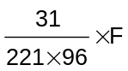 (S-band)  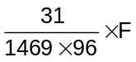 (Ku-band)  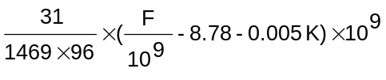(Ka-band)  Where K = 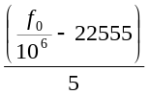  Rounded to the nearest integer if K ≠ integer and 0 < K < 198. fo is the nominal center frequency in Hz of customer platform receiver as defined by the customer MOC.
Data modulation | Modulo-2 added asynchronously to PN code
Data format (note 1) | Not Applicable
Data rate restrictions (note 1) | 0.1 - 300 kbps (S-band)  1 kbps - 300 kbps (Ku-band & Ka-band)
BPSK (PN modulation enabled; also referred to
as Spread Spectrum BPSK (SS-BPSK)) (note 2)
Command Channel
Carrier frequency (Hz) | Transmit carrier frequency (F)
PN code modulation | Phase Shift Key (PSK), + π/2 radians
Carrier suppression | 30 dB minimum
PN code length (chips) | 2¹⁰ – 1
PN code epoch reference | Refer to Appendix A
PN code family | Gold codes
PN code chip rate (chips/sec) | (S-band)  (Ku-band)  (Ka-band)  Where K =  Rounded to the nearest integer if K ≠ integer and 0 < K < 198. fo is the nominal center frequency in Hz of customer platform receiver as defined by the customer MOC.
Data modulation | Modulo-2 added asynchronously to PN code
Data format (note 1) | Not Applicable
Data rate restrictions (note 1) | 0.1 - 300 kbps (S-band)  1 kbps - 300 kbps (Ku-band & Ka-band)
Notes:
- The forward data rate in this table is the baud rate that will be transmitted by the SN (includes all coding and symbol formatting). Forward data conditioning is transparent to the SN. These transparent operations should be performed by the customer prior to transmission to the SN data interface.
- Customer’s that operate in a SS-BPSK mode for one service cannot reconfigure any of their Forward Services (i.e., MAF, SMAF, SSAF, KuSAF, or KaSAF) to an UQPSK mode. Contact Code 450 if additional flexibility is required.

Table 2 — Salient Characteristics of PN Codes for Forward Services
Parameter | Description
PN chip jitter (rms) (including effects of Doppler compensation) | <1 degree
Command/range channel PN chip skew (peak) | <0.01 chip
PN chip asymmetry (peak) | <0.01 chip
PN chip rate (peak) relative to absolute coherence with carrier rate | <0.01 chips/sec at PN code chip rate

          - Q (Range) Channel
Forward Q channel (range) shall meet the requirements specified in Table 2. Forward Q channel shall also meet requirements specified in Table 3 for PN code enabled services. These requirements are based on the current SN hardware constraints.
Table 3 — Forward Q channel PSK Service Signal Parameters
Parameter | Definition
Transmit carrier frequency (Hz) | F
QPSK (PN modulation enabled)
QPSK Range Channel
PN code modulation | PSK, + π/2 radians
Carrier suppression | 30 dB minimum
PN code chip rate | Synchronized to command channel PN code chip rate
PN code length | (2¹⁰ - 1) x 256
PN code epoch reference | All 1's condition synchronized to the command channel PN code epoch
PN code family | Truncated 18-stage shift register sequences

          - Shuttle Forward Service
Shuttle forward service using PN spreading for I (command) channel shall meet requirements specified in Table 4.

Table 4 — Shuttle Forward I (Command) Channel Requirements
Parameter | Definition
TDRS transmit carrier frequency (Hz) | F
QPSK (PN modulation enabled)
QPSK Command Channel
Carrier frequency (Hz) | Transmit carrier frequency (F)
PN code modulation | Phase Shift Key (PSK), +/- π/2 radians
PN code length (chips) | 2¹⁰ – 1
PN code epoch reference | Refer to Appendix A
PN code family | Truncated 18-stage shift register sequences
PN code chip rate (chips/sec) | 11.232 Mcps (S-band)  ≈ 3 Mcps (Ku-band)
Data modulation | Modulo-2 added asynchronously to PN code
Data format | Not Applicable
Data rate restrictions | 32 kbps & 72 kbps (S-band)  1 kbps - 216 kbps (Ku-band)

        - Return Services

Return services shall meet signal parameters relating to spread spectrum modulation provided in Table 5.
          - DG1 Mode 1

DG1 mode 1 shall be used when range and two-way Doppler measurements (coherent transponder operations) are required concurrently with return service low-rate data transmission.

For DG1 mode 1 operation, the I and Q channel PN codes shall be identical but offset by at least 20,000 chips. This separation is adequate to identify each data channel unambiguously without requiring a unique PN code for each channel. SS-BPSK is also a possible modulation for DG1 Mode 1.

          - DG1 Mode 2

DG1 mode 2 shall be used when return service signal acquisition is necessary without the requirement for prior user platform signal acquisition of the forward service (noncoherent transponder/transceiver operation).

For DG1 mode 2, the I and Q channel PN codes shall be unique 2¹¹ - 1 Gold Codes. There is no channel ambiguity in this mode since the PN codes on I and Q channels are different. SS-BPSK is also a possible modulation for DG1 Mode 2.
          - DG1 Mode 3

DG1 Mode 3 can be used when range and two-way Doppler measurements (coherent transponder operations) are required concurrently with return service high-rate data transmission.
Restrictions on DG1 mode 3 signal acquisition are identical to those for DG1 mode 1. In DG1 mode 3, the Q channel must contain only data and no PN code. MA services are unavailable for DG1 Mode 3.
There is no channel ambiguity in this mode since I/Q channel resolution is achieved by using PN correlation in addition to knowledge of I/Q power ratio.

Table 5 — Return Service Signal Parameters
Parameter | Definition
DG1 (note 1)
Transmit carrier frequency (Hz) | F1
DG1 mode 1 | 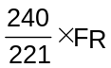 (S-band)  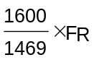 (Ku-band)
DG1 mode 2 | Customer platform transmitter oscillator
PN code modulation
DG1 modes 1 and 2 | SQPN, SS-BPSK (Refer to 450-SNUG)
DG1 mode 3, I channel | PSK +π/2 radians
PN code chip rate (chips/sec) | 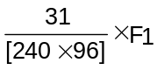(S-band)  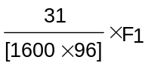 (Ku-band)
PN code length (chips)
DG1 modes 1 and 3 | (2¹⁰ - 1) x 256
DG1 mode 2 | 2¹¹ – 1
PN code epoch reference
DG1 mode 1
I channel | Epoch (all 1's condition) synchronized to epoch (all 1's condition) of received forward service Q (range) channel PN code
Q channel (note 2) | Epoch delayed x + 1/2 PN code chips relative to I channel PN code epoch
DG1 mode 2 | Not Applicable
DG1 mode 3, I channel | Same as DG1 mode 1 (I channel)
PN code family
DG1 mode 1 | Truncated 18-stage shift register sequences
DG1 mode 2 | Gold codes
Data modulation:
DG1 modes 1 and 2 | Modulo-2 added asynchronously to PN code
DG1 mode 3:
I channel | Modulo-2 added asynchronously to PN code
Q channel | PSK +π/2 radians
Notes:
- Customer platform data configurations, including specific data rate restrictions for coding and formatting, are defined in 450-SNUG for TDRSS return services (refer also to Appendix B of SNUG Rev 9). Unless otherwise stated, the data rate restrictions given in this table assume rate 1/2 convolutional encoding and NRZ formatting.
- The Q channel PN code sequence must be identical to the I channel PN code sequence; but, offset x + 1/2 PN chips, where x >20,000 (to avoid channel ambiguity). The value of x is defined by the PN code assignment for a particular customer platform. Offsetting Q channel PN sequence by ½ chip achieves SQPN modulation to prevent simultaneous transitions of the I and Q PN sequences. For data configurations that use two PN spread channels, SQPN modulation must be used.

        - Tracking Services

If PN ranging services are provided, the range estimate shall be derived by determining the time differences between the forward PN code and the coherent return PN code. When channel delays are subtracted; the result shall provide a resolution of 1 nanosecond.

When time transfer services are provided, the system shall provide PN epoch data to the user MOC for user time transfer.

    - Network Element Requirements
This section provides requirements relating to network elements. Sections 4.4.2.1 and 4.4.2.2 states requirements on transmit and receive function of the PN spread links. Section 4.4.2.3 states requirements for PN ranging.
There shall be no data transitions during the signal acquisition process if the transponder is NASA Fourth Generation Transponder compatible. In some cases the data transition during signal acquisition would result in longer acquisition times.

      - Transmit Requirements

The network element transmitter shall be capable of generating PN codes in accordance with Appendix A and 451-PN CODE SNIP. The network element shall be capable of spreading forward link data as described in Section 4.4.1.2.1.

      - Receive Requirements

The network element shall be capable of receiving the return link signal using the formats described in sections 4.4.1.2.2. The network element shall perform PN acquisition to obtain the epoch of the received code. The network element shall provide PN epoch synchronization to the transmitter for ranging turnaround.

Network element shall be capable of supporting users employing PN codes allocated to other agencies.

      - PN Ranging Requirements

If the system employs PN ranging, the network element shall be capable of computing correlation to estimate total delay. If the system employs PN ranging, the network element shall be capable of resolving delay ambiguity. The network element shall also be capable of performing range zero set functions to precisely calculate and account for processing delays through network element equipment and other related requirements.

    - User Element Equipment Requirements for PN Spreading

This section provides functional and performance requirements for user element equipment in a system employing NASA standard PN Spread modulation formats relating to the PN spread signal formats used in Space Network compatible customer platform. The requirements discussed in this section are based on the NASA Fourth Generation TDRSS User Transponder specification which is compatible with the Space Network. The NASA Fourth Generation TDRSS User Transponder requirements and parameter values are provided as an example implementation. These requirements ensure compatibility with existing Space Network PN spread modes; however, SN compatibility may be achieved with other implementations. Customer platform/equipment should be a transponder when coherent mode of operation is required; if non-coherent operation is used the user equipment may be a transceiver. Note that this section provides only those parameter requirements relating to signal compatibility. As indicated above, there are other types of requirements, not specifically related to PN spread modulation signal formats, which must be met to ensure system compatibility with existing SN hardware. Consult 450-SNUG for additional requirements that are not specific to PN spread formats.

      - Receive Requirements

The customer platform receiving system shall search for and acquire the I channel PN codes (short code). The receiving system shall be capable of de-spreading short PN codes. When using coherent mode of operation, the transponder shall be capable of providing coherent turnaround capability to the transmitter.
The customer platform receiving system shall search for and acquire the range channel PN code (long code) upon acquisition of the I (command) channel PN code and carrier. The receiving system shall be capable of de-spreading the long PN code. The customer platform shall be capable of providing PN epoch synchronization to the transmitter for ranging turnaround.
External Programming Connector shall include the state “PN code” (The user’s assigned PN code address (1 of 85 codes) must be specified) as one of the programming parameters.
      - Transmit Requirements

The customer platform shall be capable of spreading data on I channel and on Q channel using generated PN codes. The customer platform shall be capable of synchronizing the epoch of the transmitted PN code to that of the received code.
      - Transmitter Requirements for PN Spreading

Both long and short return link codes shall be produced in the customer platform in accordance with Appendix A and 451-PN CODE-SNIP with characteristics specified in Table 3.
The transmitter PN code and carrier shall be coherent with respect to each other for all modes of operation. For coherent forward link/return carrier operation, the transmitter shall be phase modulated by a long code PN sequence synchronized to the forward link. For noncoherent forward link/return link operation, the transmitter shall be phase modulated by a short code PN sequence synchronized to the Temperature Compensated Crystal Oscillator (TCXO). In either case, code modulation shall be capable of ground command disable.
          - PN Chip Rate
The PN chip rate shall meet the requirements specified in Table 3 for each of the services.
      - Receiver Requirements for PN Spreading
        - Dual Mode Search

The customer platform receiver shall simultaneously search for PN code correlation and a carrier wave (CW) signal greater than the detection threshold. Upon acquisition of one signal type, the other mode shall be inhibited until loss of initial signal and subsequent return to search mode occurs.

        - Receiver Lock Detectors

The receiver shall be capable of providing the following lock detectors:

- Sync Detect: It indicates the receiver has detected energy in the receive bandwidth and it has initiated the PN code main lobe verification routine.
- Main Lobe Detect: It indicates the receiver has concluded successfully the PN code main lobe verification routine.
- PN Lock: It indicates the receiver is locked to and tracking the short PN code.
- Long Code Detect: It indicates synchronization has been established with the long PN code.

          - PN Chip Rate
The customer platform receiver shall be capable of acquiring signals with chip rates specified in Table 1 and Table 2.
        - Performance Requirements
          - Short Code Acquisition Time

The customer platform receiver shall acquire short code PN lock with a probability of 90 percent or greater within 20 seconds after arrival of the forward link transmission.
          - Long PN Code Acquisition Time

The receiver shall establish synchronization with the long PN code with a probability specified for the system.
        - Ranging Performance
Each customer platform shall synchronize its return link PN Code epoch to the received forward link long PN code epoch for ranging. The transponder must meet the timing requirements between these epochs specified in paragraphs 4.4.3.4.4.1 through 4.4.3.4.4.4.
          - Absolute Time Delay

The nominal absolute time delay (To) between transmit and receive epochs shall be 325 nsec, which is the reciprocal of the PN chip rate, +100 nsec.
          - Time Delay Variation

The customer platform shall be designed such that the time delay, when averaged over a 100-second interval, between transmit and receive epochs (To) does not vary from its nominal value more than that specified for the network as a function of signal strength, carrier frequency, chip rate, or primary power supply voltage, either individually or in conjunction with the environmental parameters.
          - Time Delay Repeatability

The time delay for any specific set of signal and/or environmental parameters must be repeatable
within +10 nsec.
          - Short-Term Time Delay Jitter

The time delay jitter shall not exceed 10 nsec rms.
        - Time Transfer Interface Requirements
          - General

The customer platform shall provide two redundant PN code epoch outputs as shown in Figure 10 which coincide in time with the all 1’s or epoch state of the forward link long code as defined in 451- PN CODE - SNIP.

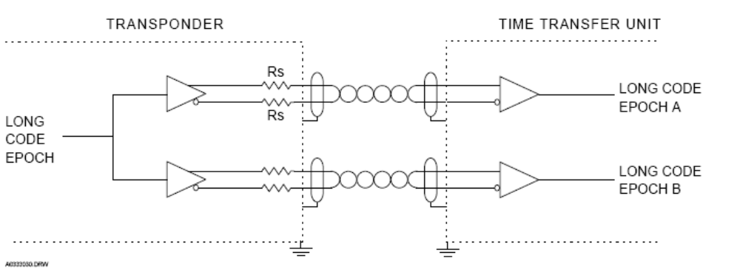
Figure 10 — Time Transfer Interface

          - Rise and Fall Times

The epoch signal rise and fall times shall not exceed 30 nsec as measured at the 10 to 90 percent points.
          - Epoch Period

The period of the epoch will nominally be determined by the equation (see Figure 11):

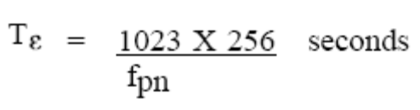

where: fpn = PN chip rate in chips/sec as determined from the received signal. The duration of the epoch signal will be nominally one PN chip.

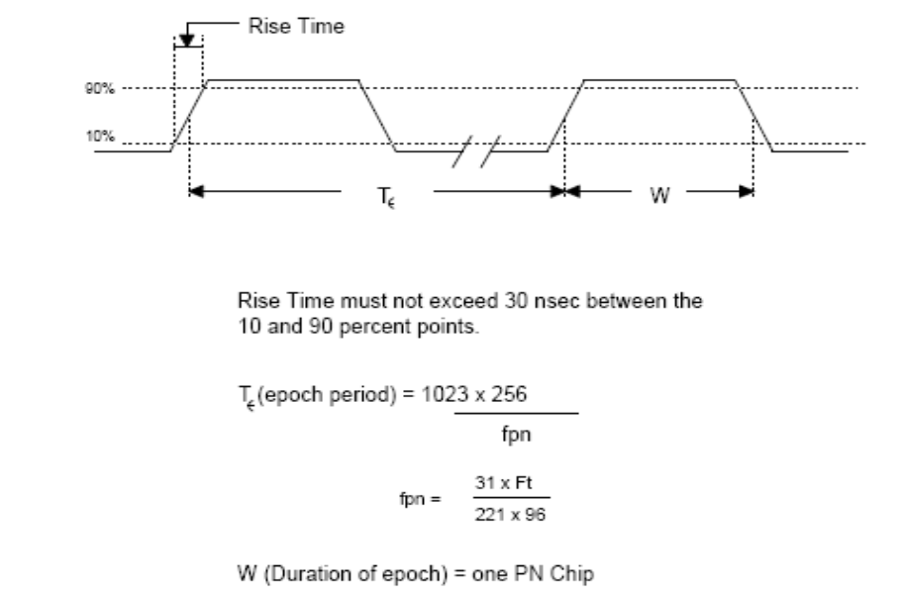
Figure 11 — Time Transfer Interface Timing Diagram

          - Epoch Timing Accuracy

The timing uncertainty between the epoch output and actual epoch transition of the receiver long code must be as specified for the network. The jitter component or sample-to-sample variation must not exceed assigned time period.
      - PN Code Performance
          - Code Modulation Coherency

The transmitter PN code and carrier shall be coherent with respect to each other for all modes of operation. For noncoherent forward link/return link operation, the transmitter shall be phase modulated by a short code PN sequence synchronized to the Temperature Compensated Crystal Oscillator (TCXO). In either case, code modulation shall be capable of ground command disable.
        - PN Chip Rate
The PN chip rate requirements provided in tables 2 and 5 shall be met for forward and return services respectively.
        - PN Code Skew

The skew between the 50 percent transition points of the I and Q channel PN codes shall be ½ chip +0.01 chip at the modulator input.
        - PN Code Asymmetry

The percent asymmetry between the 50 percent points of a high-to-low PN transition versus a
low-to-high transition shall not exceed 1 percent.

Percent asymmetry = 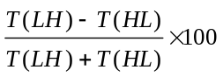 percent

        - PN Chip Jitter

a. In transmitter modes 1 and 3 the PN chip jitter must not exceed 10 nsec rms.

b. For transmitter mode 2, the PN chip jitter must not exceed 4 nsec rms.

      - Bilevel Status Telemetry

The customer platform shall provide the bilevel status signals in RT Subaddress 2 as specified in Table 6 for PN codes.
Table 6 — Bilevel Telemetry Involving PN Codes
RT  Sub-address | Word | Bit  Assign-ment | Function | False State  (Bit = 0) | True State  (Bit = 1) | Update  frequency  (updates/sec)
2 | 1 | 01 | PN Lock (PNL) | PN code loop is not locked | PN code tracking is locked to TDRSS forward link code | 5
2 | 1 | 03 | Long Code detect  (LCDET) | No synchronization with the long code | Indicates synchronization has been established with the range code | 5
2 | 1 | 05 | Sync detect (SYNC) | Receiver is in search mode | Indicates synchronization has been established with the short forward link  PN code | 5
2 | 1 | 13 | I PN disable (INHI) | I PN code has been inhibited from  modulating the return link carrier | I PN code is enabled | 5
2 | 1 | 14 | Q PN disable  (INHQ) | Q PN code has been inhibited from  modulating the return link carrier | Q PN code is enabled | 5

APPENDIX A
NASA SPECIFIC PN CODE REQUIREMENTS
(Properties, Criteria and Selection Requirements)
NASA systems designed to be Space Network compatible shall meet the requirements specified in this appendix when implementing PN codes. 451-PN CODE-SNIP provides libraries of PN codes that NASA systems can use which meets all the requirements specified in this appendix.
NASA services use Gold codes and Maximal Length Codes for various services. This appendix provides details on specific PN code properties, generation criteria, and code selection for each of the services that use PN spread modulation.
  - Gold Codes for NASA Systems
Gold Codes are used by NASA in the Forward I channel (Command Link) and Return Mode 2 links. The codes differ only in the initial conditions of the shift registers. The following sections explain Gold Codes used in these links in detail.
    - Command Link Gold Codes
Figure 12 provides the Gold code generator circuit used in the Forward Command Link. Command link circuit uses two single-shift registers of length 10. The feedback taps are the same for each agency and the codes only differ in the initial conditions of Register A. For NASA Command link the initial conditions are given in table 1.
      - Command Link Properties
The set of Gold codes corresponding to this circuit hold the following properties:
- A total of 2¹⁰ + 1 = 1025 sequences (codes) can be generated by altering the initial conditions of only one of the shift registers
- Each code is 2¹⁰ – 1 = 1023 symbols long
- Of the 1025 codes, 355* are balanced codes, i.e. each code has precisely 512 ones and 511 zeros.

It should be noted that the circuit of Figure 12 for which this property holds contains a “zero” in stage 1 of register A. A detailed discussion of this constraint is provided in 451- PN CODE - SNIP.

Table 7 — NASA Unique Initial Conditions for PN Code Generation for Command Link
Initial Conditions  Register A  Stage Number: |  | Agency | Balanced Codes | Assigned Codes | Unassigned Codes
10 | 9
0 | 0 | NASA | 85 | 85 | 0

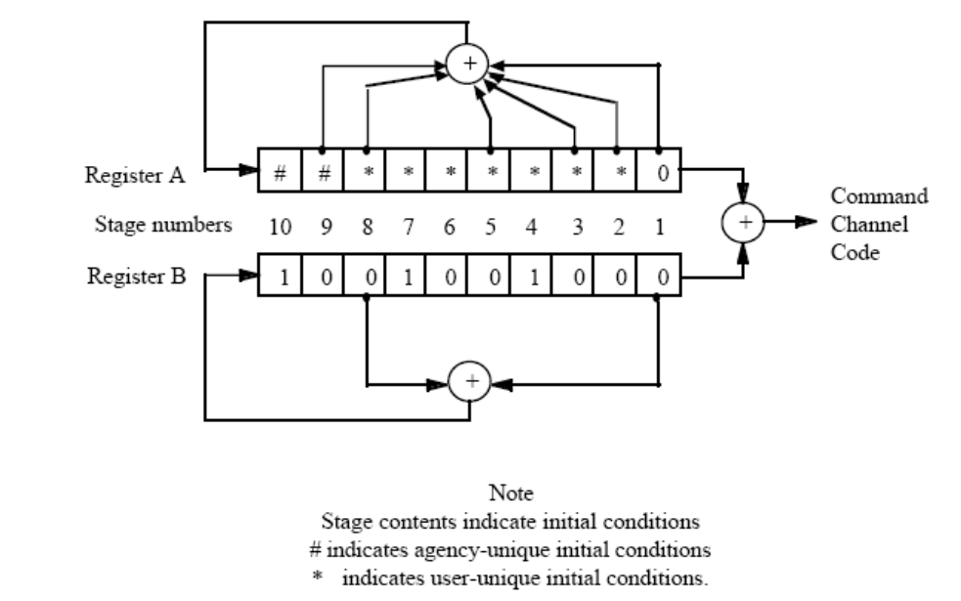
Figure 12 — Command Link Gold Code Generator

      - Command Link Code Criteria

Balance and low cross correlation values are considered as the selection criteria for the Forward Command Link PN code libraries. A balanced code is one in which the number of "ones" is one more than the number of "zeros". This type of code is preferable due to its smooth transmitted spectrum. It is also desirable to use codes that are "unique", which is accomplished by choosing codes with low cross correlation values. Because Command Codes are Gold Codes, they have minimum cross correlation values. Not only are the side lobes small compared to the maximum auto correlation value (2^{N} - 1), but the frequency of occurrence is also relatively small.

      - Command Link Code Selection

The Command Link Code Libraries were modeled after the circuit shown in Figure 13. Figure 14 depicts an example of a forward command channel code generator configuration with initial conditions. During the selection, stage 1 of register A contains a "zero".

Each Forward Command Link library consists of only 85 codes. NASA's initial conditions for stages 10 and 9 of register A produce only 85 balanced codes, therefore no selection method needed to be established and there will be no unassigned codes.

The Command Link code assignments are listed in 451-PN CODE-SNIP. The GSFC Spectrum Manager shall assign PN codes for each user.
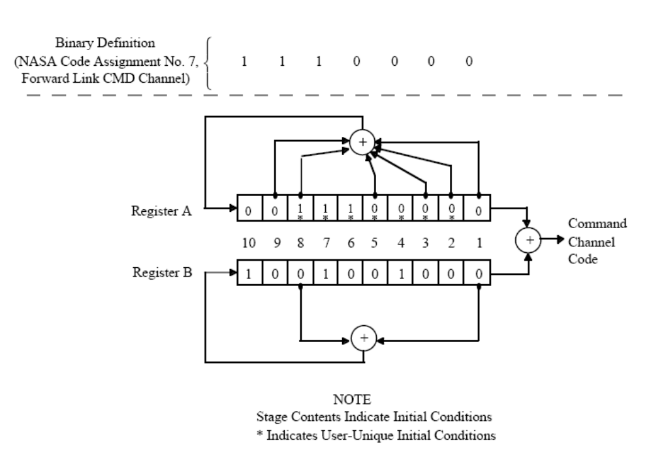
Figure 13 — Command Link Gold Code Generator Initial Conditions

    - Return Mode 2 Link Gold Codes
      - Return Mode 2 Link Properties
Figure 14 shows the Gold code generator for Return Mode 2 link (non-coherent turnaround mode).
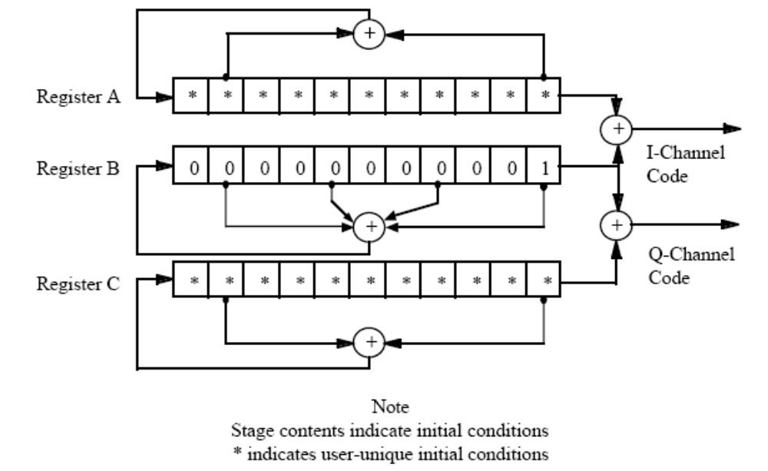
Figure 14 — Return Mode 2 Link Gold Code Generator

This circuit is composed of three single-shift registers of length 11. The feedback taps are the same for each agency's library. The codes only differ in the initial conditions of Registers A and
C for each agency. The set of Gold Codes associated with this circuit has the following properties:

- There are 2¹¹ + 1 = 2049 codes generated by altering the stage contents of one of the two shift registers (register A for the I channel codes and register C for the Q channel codes)
- Each code is 2¹¹ - 1 = 2047 symbols long
- Of the 2049 codes, there are 2¹⁰ + 1 = 1025 balanced codes in the set

      - Return Mode 2 Link Code Criteria

The following four criteria are considered in the selection of the Return Mode 2 Link PN code libraries: balance, low cross correlation values, no duplicate code assignments, and minimized spurious code effects. A balanced code is preferable because it will have a smooth transmitted spectrum. It is also desirable to use codes that are "unique", which is accomplished by choosing codes with low cross correlation values. Because these codes are Gold Codes, they have minimum cross correlation values. Not only are the side lobes small compared to the maximum auto correlation value (2^{N} - 1), but the frequency of occurrence is also relatively small. To avoid interference, I or Q code assignments should not be duplicated. Spurious codes are caused by the filtering and hard-limiting of a staggered quadriphase PN (SQPN) signal. If a spurious code matches an assigned code, false lock may occur and thus cause interference. To avoid this type of interference, codes are selected to ensure that such spurious code matches are not generated.

It has been shown that if the Q channel sequence is delayed 1/2 chip (SQPN) then the spurious sequences generated on the I and Q channels due to filtering and hard-limiting are:

I channel spur = i ⊕ q ⊕ q1

Q channel spur = q ⊕ i-1 ⊕ i

where i and q are the binary sequences on the I and Q channel respectively, q1 is the q sequence delayed by one chip and i-1 is the i sequence advanced by one chip.

In Figure 14, registers A and C are identical, so i and q are members of the same Gold code set.
Term by term modulo 2 addition of two members of a set of PN codes results in another member of the same PN code set. From the equations above, it is obvious that the spurious codes which occur on the I and Q channels are also members of the same set of Gold codes and therefore are capable of causing "false lock". To avoid the possibility of false lock, the choice of I and Q channel code pairs must be made so that the spurious codes on the I and Q channels do not duplicate any of the 510 gold codes assigned to NASA, ESA or JAXA's Return Mode 2 Link libraries. A detailed analysis of spurious codes is found in 451- PN CODE - SNIP.

      - Return Mode 2 Link Code Selection

The Return Mode 2 Link Code Libraries were modeled after the circuit shown in Figure 14. There are no restrictions on the initial conditions of Register A and C. The initial conditions are expressed as four digit octal numbers. Each octal digit is converted to its three bit binary representation, giving a twelve digit binary number. Since the circuit design has only eleven registers, the most significant digit is truncated. Figure 15 demonstrates an initial condition conversion from octal to binary. Figure 16 shows the initial conditions of registers A and C for the example shown in Figure 15.

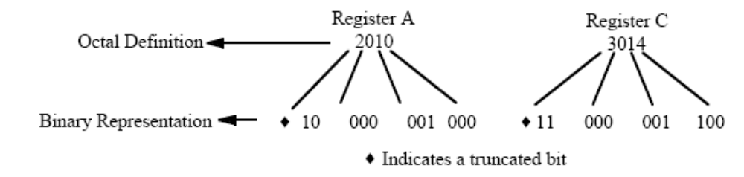
Figure 15 — Octal Conversion Example

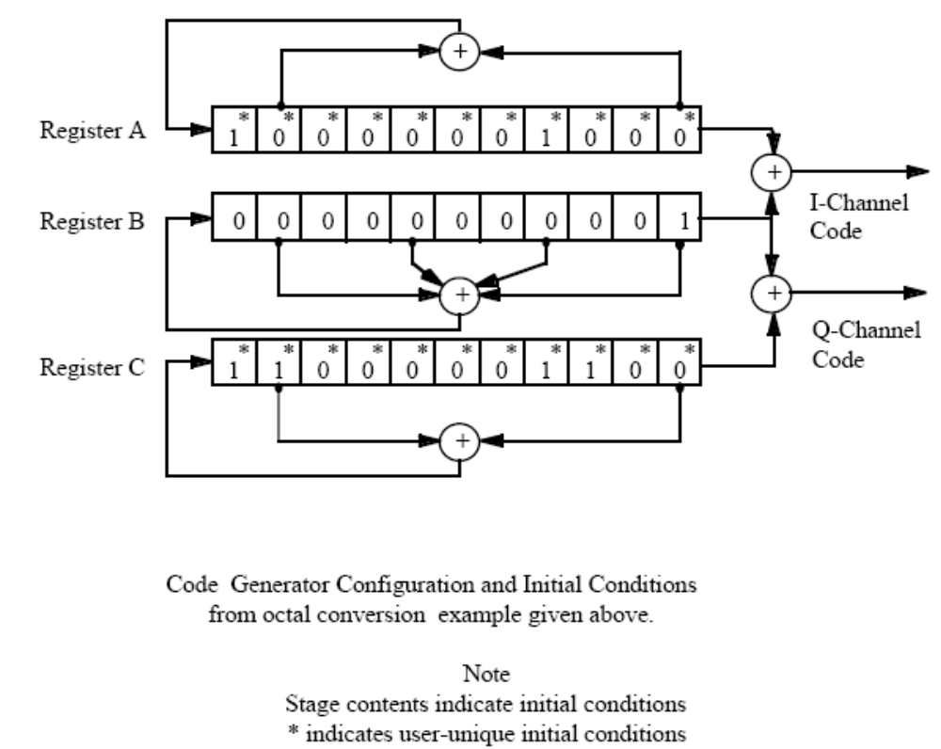
Figure 16 — Code Generator Configuration and Initial Conditions
for Octal Conversion Example

The NASA Return Mode 2 Code library (previously assigned) employs the fact that if the initial condition of the spurious code is all zeroes, then the spurious code is a maximal length code and not a Gold Code. Therefore, interference due to false lock is minimized since the spurious maximal length code would not be mistaken for an assigned Gold Code. This criteria was applied to the spurious Q codes of the NASA, ESA, and JAXA Return Mode 2 code libraries.

The Return Mode 2 Link code assignments are listed in 451-PN CODE-SNIP. The GSFC Spectrum Manager shall assign PN codes for each user.

  - Maximal Length Codes for NASA Systems
NASA uses Maximal Length Codes for Forward Range Channel, Return Modes 1 and 3 Links, and Forward Shuttle S-band Command Links.

Sets of maximal length codes (M-sequences) are produced by varying the feedback tap locations, given the constraints on the total number of taps. The set from which the Return Modes 1 and 3 Link Code libraries are selected contains code possibilities with eight or fewer taps, and the set from which the Ranging Code libraries are selected is restricted to the possible tap combinations with six or fewer taps. The NASA specific Shuttle S-band Forward Command Link library is selected with two or four feedback taps.

    - Forward Range Channel Codes
      - Forward Range Channel Properties

The circuit used to generate the Range Channel Codes is an 18 stage register with as many as six
tap connections, as shown in Figure 17.
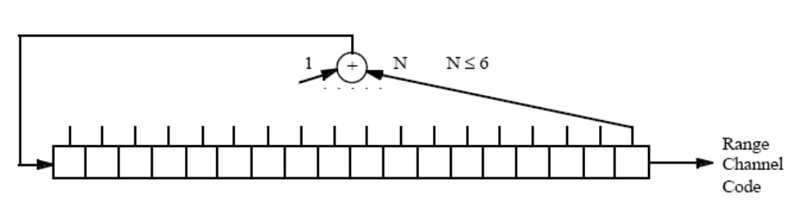
Figure 17 — Range Channel Code Generator

The initial conditions for the Ranging Code circuit depicted above are the same for each code. The codes differ in their unique feedback tap assignments. Libraries of codes were selected from the set having the following properties:

- Codes are of length 2¹⁸ - 1 = 262143
- Codes are truncated to an integer multiple (256) of the command code length, (2¹⁰ - 1)*256 = 261888. The all 1's initial condition of the register is synchronized to the 1001001000 state of the B register of the Command Channel Code generator as shown in Figure 12. Thus, the last 262143-261888=255 bits of the code are not generated before the shift register is reset to its initial all 1's condition. This synchronization and truncation process permits rapid acquisition of the longer code using the short code.
- 792 maximal length codes are possible with six or fewer taps.
      - Forward Range Channel Code Criteria

The following criteria were considered in the selection of the Forward Ranging Channel PN Code libraries: maximal length and balance. Maximal length codes are required to ensure that the full transmitted sequence of 262143 (truncated to 261888) bits is not a repeated periodic subsequence, thus avoiding false lock. Maximal length codes are produced by corresponding primitive polynomials, as shown in Figure 18. See Appendix B for a detailed description of the criteria for producing maximal length codes.
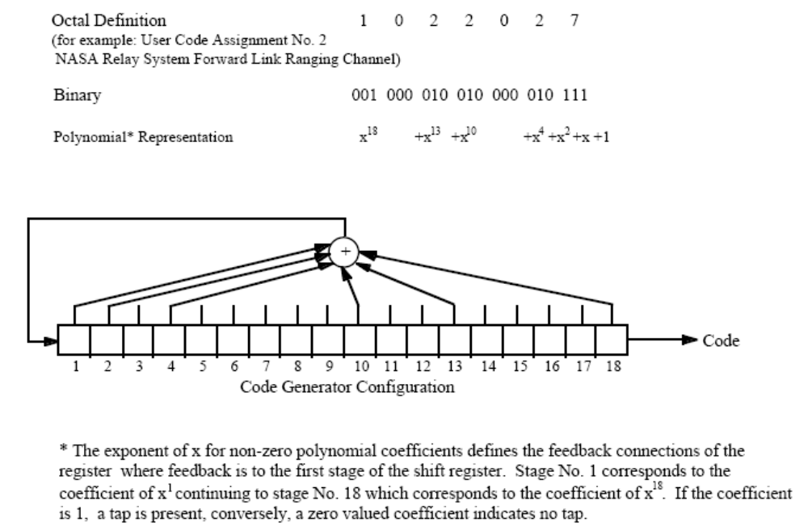
Figure 18 — Range Channel Code Feedback Tap Example

Additionally, maximal length codes exhibit the favorable property of balance, which ensures a smooth transmitted spectrum. Balance is defined as having one more "one" than "zero". For the Ranging Codes, however, the full code is not transmitted; thus the truncated balance is of interest. The balance of the truncated code produced for the Forward Ranging Channel is at most off by a factor of 255/262143, approximately 0.1%. Thus, it is assumed that all codes are "essentially" balanced.

      - Forward Range Channel Code Selection

The Range Channel Code libraries were modeled after the circuit in Figure 18. This figure also shows the relationship between the octal definition of the code, as listed in the libraries, and the corresponding shift register feedback tap locations. NASA has been assigned 85 codes meeting the above described criteria.

The Forward Range Link code assignments are listed in 451-PN CODE-SNIP. The GSFC Spectrum Manager shall assign PN codes for each user.

    - Return Modes 1 and 3 Link Codes
      - Return Modes 1 and 3 Link Properties

Figure 19 shows the circuit used to generate the Maximal Length Codes for the Return Mode 1 and Mode 3 Links.
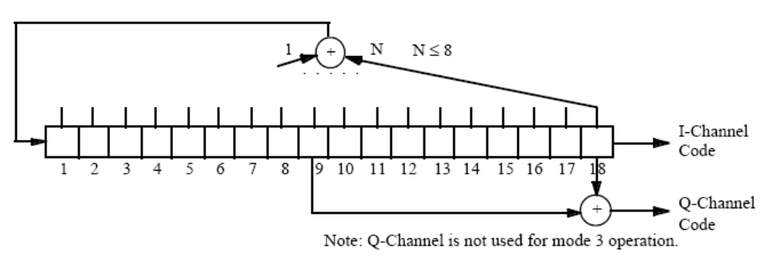
Figure 19 — Return Modes 1 and 3 Link Code Generator

The above circuit is an eighteen-stage linear shift register utilized for the Return Modes 1 and 3 Link Codes. Mode 1 uses both the I and the Q Channels, while Mode 3 uses only the I-Channel code. The Q-Channel code is generated by modulo two summing the ninth and eighteenth stages, as shown in the figure above. The assigned codes differ in their unique feedback tap assignments. The maximum number of feedback taps is eight. The initial conditions are the same for each code, an all 1's condition. Libraries of codes were selected from the set having the following properties:

  - Codes are of length 2¹⁸ - 1 = 262143
  - Codes are truncated to 261888 to synchronize the shift register with the Forward Range channel. Thus, the last 262143 - 261888=255 bits of the code are not generated before the shift register is reset to its initial all 1's condition
  - 3088 maximal length codes are possible with eight or fewer taps.
      - Return Modes 1 and 3 Link Code Criteria

The following criteria were considered in the selection of the Return Modes 1 and 3 Link PN Code libraries: maximal length, balance, a channel offset in excess of 20000 chips, and minimized spurious code effects. Maximal length codes are produced by shift registers with corresponding primitive polynomials as depicted in the Return Modes 1 and 3 Feedback Tap Example of Figure 20. Maximal length codes assure certain favorable properties. See Appendix B (Algorithm for Selecting Primitive Polynomial) for a detailed description of the maximal length codes.

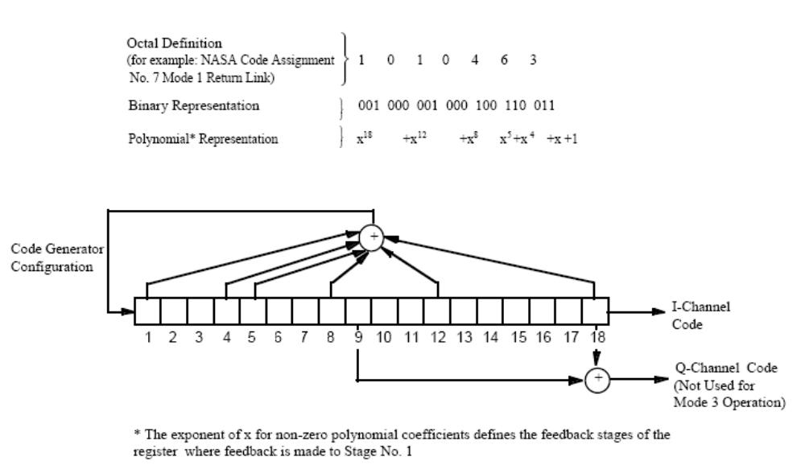

Figure 20 — Return Modes 1 and 3 Link Feedback Tap Example

A balanced code is desired due to its smooth transmitted spectrum. In the case of maximal length codes, the balance is assured when there is one more "one" than "zero". The full code is not transmitted; rather it is the truncated balance that is of interest. The balance of the truncated code produced for the Return Modes 1 and 3 Link Channel is at most off by a factor of 255/262143, approximately 0.1%. Thus it is assumed that all codes are "essentially" balanced. Since dual channels are used for Mode 1 operations, assigned codes must have an I to Q (or Q to I) channel difference greater than 20,000 chips to avoid channel ambiguity. As depicted in Figure 19, the I and Q Channel codes are simultaneously generated by the same shift register. The Q-channel code is the modulo two addition of two phase shifted versions of the I-Channel code. Employing a basic property of binary maximal length sequences, the Q-Channel is simply a shifted version of the I Channel.

In order to minimize the spurious code effects created by filtering and hard limiting, a minimum offset of 5000 chips is imposed between the codes and the spurious codes generated. This is necessary to avoid interference, because the spurious codes are simply a shifted version of the channel codes. This is obvious by the shift and add property given in the equations below:

I channel spur = i ⊕ q ⊕ q1
Q channel spur = q ⊕ i-1 ⊕ i

where i and q are the binary sequences on the I and Q channels respectively, q1 is the q sequence delayed by one chip and i-1 is the i sequence advanced by one chip. A detailed analysis of spurious codes is found in 451- PN CODE - SNIP.

      - Return Modes 1 and 3 Link Code Selection

The Return Modes 1 and 3 Link Code libraries were modeled after the circuit in Figure 19. The relationship between the octal definition of the library codes and the corresponding shift register feedback tap locations is seen in Figure 19. NASA has been assigned 85 codes. Due to an inconsistency in the derivations of the spurious code offsets, six of the NASA codes do not meet the above stated 5000 chip requirement. All remaining code assignments adhere to the specified criteria.

A Forward Range Code could meet all of the criteria imposed on the Modes 1 and 3 Link codes.
However, any assigned Forward Ranging Codes were eliminated from the possible codes for the
Return Modes 1 and 3 Link libraries to be used by ESA and JAXA.

The Return Modes 1 and 3 Link code assignments are listed in 451-PN CODE-SNIP. The GSFC Spectrum Manager shall assign PN codes for each user.
    - Shuttle S-band Forward Command Link Codes
      - Shuttle S-band Forward Command Link Properties

The circuit used to generate the Shuttle S-band Command Codes is a 10 stage register with two or four tap connections, as shown in Figure 21.

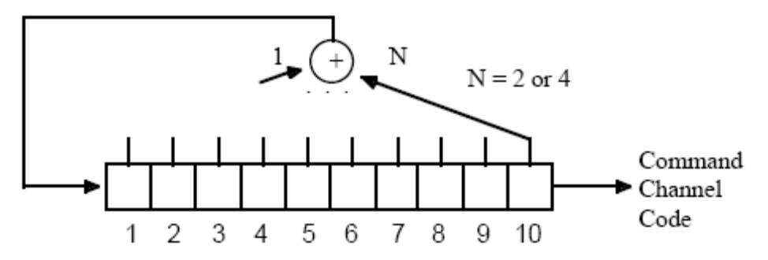
Figure 21 — Shuttle S-band Command Code Generator

The initial conditions for the Shuttle S-band Command Code circuit depicted above are the same for each code. The codes differ in their unique feedback tap assignments. The NASA specific library of codes was selected based upon the following properties:

  - Codes are of length 2¹⁰ - 1 = 1023
  - The initial condition of the register is all 1's
  - Two or four feedback taps.
      - Shuttle S-band Forward Command Link Code Criteria

The following criteria were considered in the selection of the Shuttle S-band Forward Command PN Code libraries: maximal length and balance. Maximal length codes are required to ensure that the full transmitted sequence of 1023 bits is not a repeated periodic subsequence, thus avoiding false lock. Maximal length codes are produced by corresponding primitive polynomials, as shown in Figure 22.
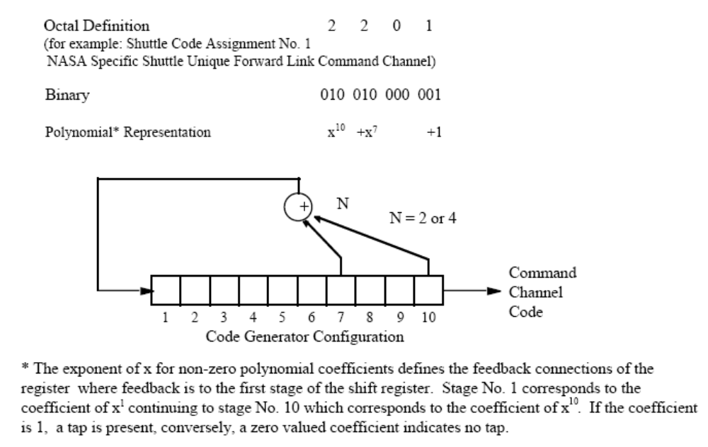
Figure 22 — Shuttle S-band Feedback Tap Example

Additionally, maximal length codes exhibit the favorable property of balance, which ensures a smooth transmitted spectrum. Balance is defined as having one more "one" than "zero".
      - Shuttle S-band Forward Command Link Code Selection

The Shuttle S-band Command Code libraries were modeled after the circuit in Figure 22. This figure also shows the relationship between the octal definition of the code, as listed in the libraries, and the corresponding shift register feedback tap locations. The NASA specific Shuttle Forward Link Command library consists of 4 codes meeting the above described criteria.
The Shuttle S-band Command Link code assignments are listed in 451-PN CODE-SNIP. The GSFC Spectrum Manager shall assign PN codes.

APPENDIX B

Algorithm for Selecting Primitive Polynomials

Although much work has been done on maximal length codes, of the published tables available, a complete listing of primitive polynomials of order 18 was not found. It is the property of primitiveness of the characteristic polynomial that assures maximal length of the generated code.
Therefore, software was written to test all possible codes meeting system requirements for primitiveness following the procedure described herein.

Two basic facts about shift registers producing maximal length codes can be employed to eliminate codes and decrease the set to be studied:

- There must be a tap in the register corresponding to the highest order coefficient of the characteristic polynomial; and,
- There must be an even number of taps.

Using these criteria alone, combinational analysis will show that it is possible to construct 6885 codes using two, four, or six taps, and to construct 19448 codes using eight taps. However, these will not necessarily guarantee M-sequences or exhibit other desirable properties.

For a shift register to produce a code of maximal length, the corresponding characteristic polynomial must be primitive. That is to say, given an irreducible characteristic polynomial of degree n, the polynomial is primitive if and only if it divides x^{m} -1 for no m less than 2^{n} -1. In using this condition to test for primitiveness, a polynomial must be irreducible. A polynomial is irreducible if it is not divisible by any polynomial of order less than itself, except the polynomial, p(x) = 1. Software was written to test each possible polynomial for irreducibility. It was found that 1503 polynomials of 9 terms (corresponding to a shift register of 8 taps) were irreducible, and that 4316 polynomials of 3, 5, or 7 terms (corresponding to a shift register of 2, 4, or 6 taps) were irreducible.

Consider the set of irreducible polynomials of degree n; if n is a prime number, then the polynomial is said to be primitive. In this study, n is equal to eighteen, which is not prime; therefore, further investigation is necessary. Thus, the following definition applies:

Given an irreducible characteristic polynomial of degree n, the polynomial is primitive if and only if it divides x^{m} - 1 for no m less than 2^{n} - 1.

An algorithm used to determine if a given polynomial is primitive is described below:

- Compute residues, or remainders, of 1, x, x2, x4, x8, ..., x2n-1 modulo the characteristic equation, f(x).

- Multiply and reduce to form the residue of x2^{n} - 1. If the result is not 1, the polynomial is rejected. If the result is 1, the test is continued.

- For each factor r of 2^{n} - 1, compute the residue of xr by multiplying the appropriate combination of residues from step (1). If none of these is 1, the polynomial is primitive.

The above algorithm does not assume that the polynomials are irreducible; in fact, step (2) is always true for irreducible polynomials. Restricting the polynomial test set to those proven to be irreducible, as was done in this case, enables the two approaches to be combined.

The procedure used for this analysis is as follows:

- Compute factors of 2^{n} -1 = 2¹⁸ - 1 = 262143. There are a total of 29 factors, excluding 1 and 262143.
- Eliminate all factors less than 18, i.e., 3,7,9. This can be done since the algorithm tests for residues and the remainder in these cases would be the factor itself, thus passing the condition outlined in step (3). A total of 26 factors remain.
- For each of the 26 factors, r, show that the remainder of xr divided by the characteristic equation, f(x), is not equal to 1. If this fails for any of the factors, then f(x) is not primitive. Otherwise f(x) is primitive and will produce a maximal length code.

Software was developed, implementing the above algorithm, and used to test each of the irreducible polynomials in the test set for primitiveness.

